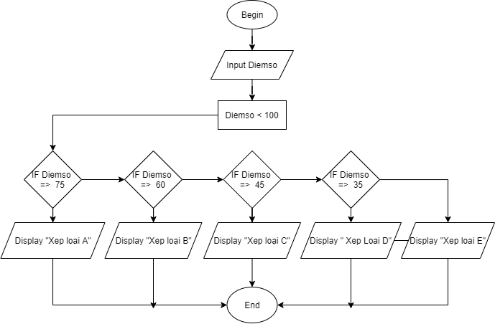

**Begin**

**Input** Diemso

**IF** Diemso <100

**IF** Diemso => 75

**Display** “ Xep loai A”

**IF** Diemso =>60

**Display** “Xep loai B”

**IF** Diemso =>45

**Display** “Xep loai C”

**IF** Diemso =>35

**Display** “Xep loai D”

**Else Display** “Xep loai E”

**End**